Alphonz George

T11-03

AIM: To make a Book store using HTML and CSS and add animations

THEORY: Hypertext Markup Language (HTML) is the standard markup language for documents designed to be displayed in a web browser. It defines the content and structure of web content. It is often assisted by technologies such as Cascading Style Sheets (CSS) and scripting languages such as JavaScript.

Web browsers receive HTML documents from a web server or from local storage and render the documents into multimedia web pages. HTML describes the structure of a web page semantically and originally included cues for its appearance.

PROGRAM: <!DOCTYPE html>

<html>

<head>

<title>Bookstore</title>

<link rel="stylesheet" type="text/css" href="style.css">

<style>

/* Internal CSS for Typography */ h2 {

font-family: 'Playfair Display', serif; font-weight: bold;

}

p {

font-family: 'Roboto', sans-serif; line-height: 1.6;

}

</style>

</head>

<body>

<!-- Dark Mode Toggle Button -->

<button id="darkModeToggle">Toggle Dark Mode</button>

<!-- Page Content -->

<h1>Welcome to Our Bookstore</h1>

<!-- Navigation Menu -->

<h3>Menu</h3>

<ul>

<li><a href="#bestsellers">Bestsellers</a></li>

<li><a href="#newarrivals">New Arrivals</a></li>

<li><a href="#categories">Categories</a></li>

<li><a href="#contact">Contact Us</a></li>

<li><a href="#audiobook">Audio Samples</a></li>

<li><a href="#register">Register</a></li>

</ul>

<!-- Bestsellers Section -->

<h2 id="bestsellers">Bestsellers</h2>

<table>

<tr>

<th>Book Cover</th>

<th>Title</th>

<th>Author</th>

<th>Price</th>

</tr>

<tr>

<td><img src="imgs/one piece.jpg" alt="Book Cover 1" width="100"></td>

<td>The Great Gatsby</td>

<td>F. Scott Fitzgerald</td>

<td>$10.99</td>

</tr>

<tr>

<td><img src="imgs/naruto.jpg" alt="Book Cover 2" width="100"></td>

<td>1984</td>

<td>George Orwell</td>

<td>$8.99</td>

</tr>

</table>

<!-- New Arrivals Section -->

<h2 id="newarrivals">New Arrivals</h2>

<ol>

<li>

<img src="imgs/61M42of+uTL._AC_UF1000,1000_QL80_.jpg" alt="New Arrival 1" width="100">

<p><strong>Title:</strong> The Silent Patient</p>

<p><strong>Author:</strong> Alex Michaelides</p>

<p><strong>Price:</strong> $14.99</p>

</li>

<li>

<img src="imgs/wan.jpeg" alt="New Arrival 2" width="100">

<p><strong>Title:</strong> Where the Crawdads Sing</p>

<p><strong>Author:</strong> Delia Owens</p>

<p><strong>Price:</strong> $12.99</p>

</li>

</ol>

<!-- Categories Section -->

<h2 id="categories">Categories</h2>

<ol>

<li>Fiction</li>

<li>Non-Fiction</li>

<li>Children's Books</li>

<li>Science Fiction</li>

<li>Biographies</li>

</ol>

<!-- Contact Us Form -->

<h2 id="contact">Contact Us</h2>

<form action="submit_form.php" method="post">

<p><label for="name">Name:</label>

<input type="text" id="name" name="name"></p>

<p><label for="email">Email:</label>

<input type="email" id="email" name="email"></p>

<p><label for="message">Message:</label>

<textarea id="message" name="message"></textarea></p>

<p><input type="submit" value="Submit"></p>

</form>

<!-- Audio Samples Section -->

<h2 id="audiobook">Audio Samples</h2>

<p>Listen to a sample of our audiobooks:</p>

<audio controls>

<source src="audio_sample.mp3" type="audio/mp3"> Your browser does not support the audio element.

</audio>

<!-- Register Section -->

<h2 id="register">Register</h2>

<form action="register.php" method="post">

<p><label for="username">Username:</label>

<input type="text" id="username" name="username"></p>

<p><label for="password">Password:</label>

<input type="password" id="password" name="password"></p>

<p><label for="email">Email:</label>

<input type="email" id="email" name="email"></p>

<p><label for="dob">Date of Birth:</label>

<input type="date" id="dob" name="dob"></p>

<p><input type="submit" value="Register"></p>

</form>

<!-- Script for Dark Mode Toggle -->

<script>

const toggleButton = document.getElementById('darkModeToggle'); toggleButton.addEventListener('click', () => {

document.body.classList.toggle('dark-mode');

});

</script>

</body>

</html>

External CSS file:

/* External CSS File */

/* Color Mode: Light and Dark Mode */

:root {

--background-color: #f5f5f5;

--text-color: #333;

--header-bg-color: rgba(76, 116, 175, 1);

--menu-bg-color: rgba(51, 51, 51, 0.9);

--menu-hover-color: rgba(17, 17, 17, 0.9);

--form-bg-color: rgba(255, 255, 255, 0.8);

}

body.dark-mode {

--background-color: #121212;

--text-color: #e0e0e0;

--header-bg-color: rgba(76, 116, 175, 1);

--menu-bg-color: rgba(38, 38, 38, 0.9);

--menu-hover-color: rgba(26, 26, 26, 0.9);

--form-bg-color: rgba(48, 48, 48, 0.8);

}

/* General Body Styling */ body {

font-family: 'Roboto', sans-serif; background-color: var(--background-color); color: var(--text-color);

margin: 0;

padding: 0;

transition: background-color 0.3s ease, color 0.3s ease;

}

/* Header Styling */

h1 {

background-color: var(--header-bg-color); color: white;

padding: 20px; text-align: center; border-radius: 5px;

font-family: 'Playfair Display', serif; transition: background-color 0.3s ease;

}

/* Navigation Menu */ ul {

list-style-type: none; margin: 0;

padding: 0; overflow: hidden;

background-color: var(--menu-bg-color); transition: background-color 0.3s ease;

}

ul li {

float: left;

}

ul li a {

display: block; color: white;

text-align: center; padding: 14px 16px; text-decoration: none;

transition: background-color 0.3s ease, transform 0.3s ease;

}

ul li a:hover {

background-color: var(--menu-hover-color); transform: scale(1.1);

}

/* Table Styling */ table {

width: 100%;

border-collapse: collapse; margin: 20px 0;

font-size: 18px; text-align: left;

background-color: var(--form-bg-color); transition: background-color 0.3s ease;

}

table th, table td { padding: 12px;

border-bottom: 1px solid #ddd;

}

table th {

background-color: var(--header-bg-color); color: white;

}

/* Image Styling */ img {

border-radius: 5px;

transition: transform 0.3s ease;

}

img:hover {

transform: rotate(5deg);

}

/* Form Styling */ form {

background-color: var(--form-bg-color); padding: 20px;

border-radius: 5px; margin: 20px 0;

transition: background-color 0.3s ease;

}

form p {

margin: 10px 0;

}

form input[type="text"], form input[type="email"], form input[type="password"], form input[type="date"], form select,

form textarea { width: 100%; padding: 12px;

border: 1px solid #ccc; border-radius: 4px; box-sizing: border-box; margin-top: 6px; margin-bottom: 16px; resize: vertical;

}

form input[type="submit"] {

background-color: var(--header-bg-color); color: white;

padding: 14px 20px; border: none; border-radius: 4px; cursor: pointer;

transition: background-color 0.3s ease, transform 0.3s ease;

}

form input[type="submit"]:hover {

background-color: rgba(69, 160, 74, 0.9); transform: scale(1.05);

}

/* Ordered List Styling */ ol {

counter-reset: section;

}

ol li {

margin-bottom: 10px; padding-left: 20px; position: relative;

transition: transform 0.3s ease;

}

ol li:before {

content: counter(section) ". "; counter-increment: section; position: absolute;

left: 0;

font-weight: bold;

}

ol li:hover {

transform: translateX(10px);

}

/* Pseudo-classes and Pseudo-elements */ a:hover {

color: #4c74af;

text-decoration: underline;

}

h2::first-letter {

font-size: 200%; color: #4c74af;

}

/* Button for Dark Mode Toggle */ #darkModeToggle {

position: fixed; top: 20px; right: 20px;

background-color: #333; color: white;

border: none; padding: 10px; cursor: pointer; border-radius: 5px;

transition: background-color 0.3s ease;

}

#darkModeToggle:hover { background-color: #555;

}

OUTPUT:

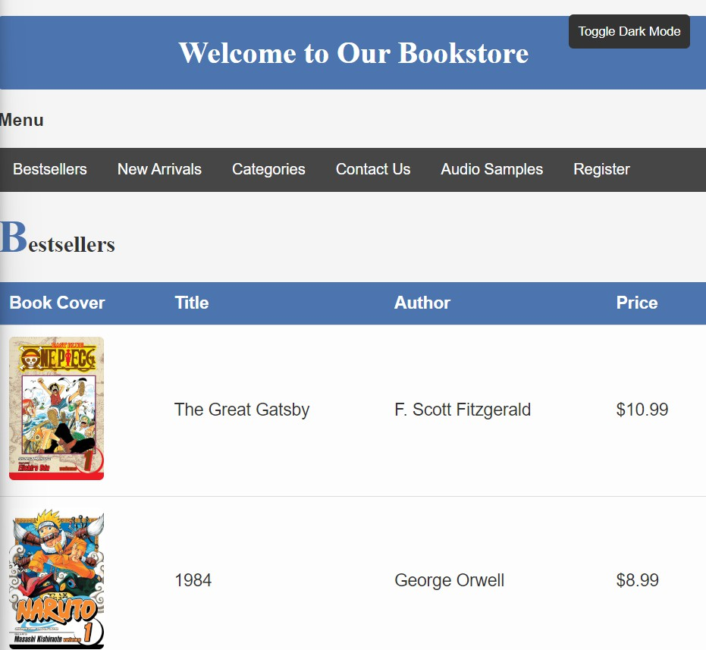

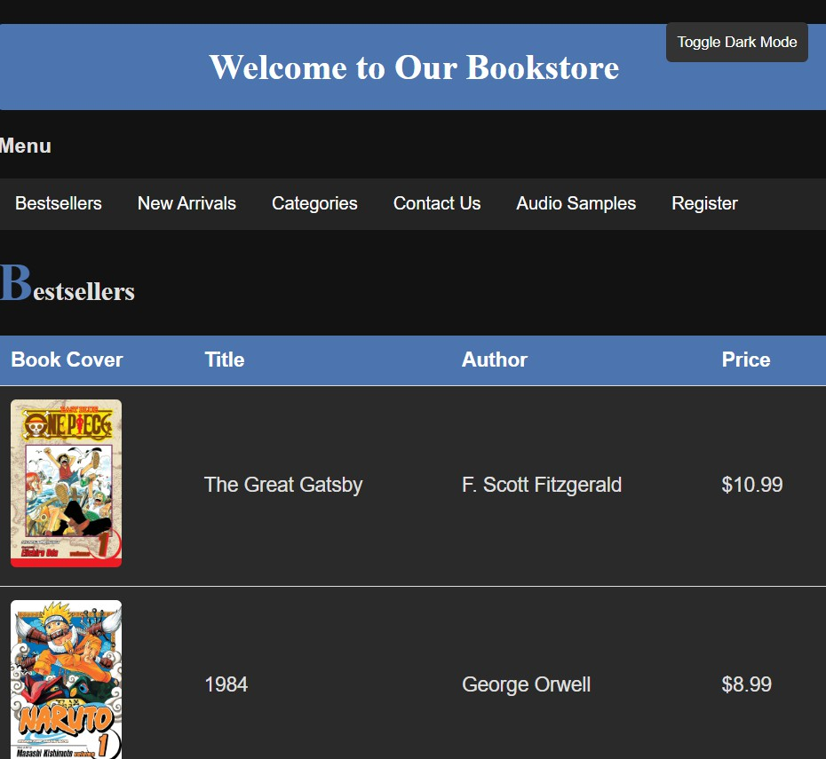

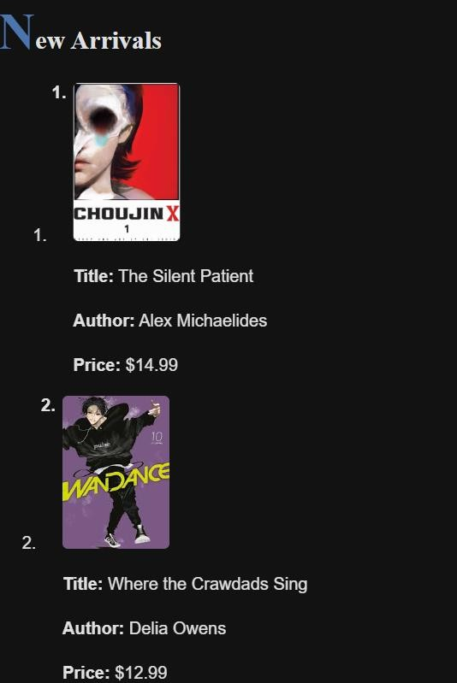

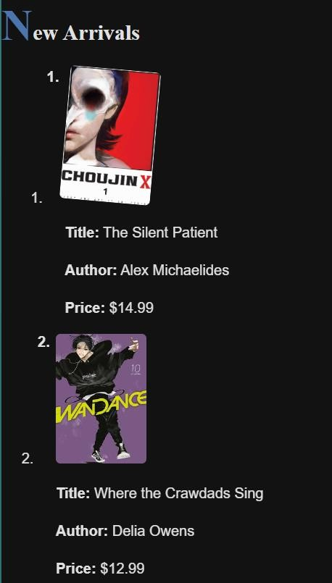

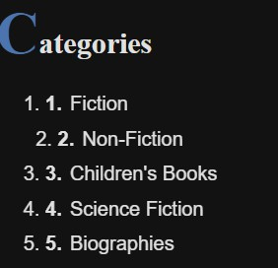

CONCLUSION: This is the required output.